**CROSS ENTROPY LOSS**

THIS IS THE MOST COMMON SETTING FOR CLASSIFICATION PROBLEMS. CROSS-ENTROPY LOSS INCREASES AS THE PREDICTED PROBABILITY DIVERGES FROM THE ACTUAL LABEL.

CROSS ENTROPY MEASURES THE DIVERGENCE BETWEEN TWO PROBABILITY DISTRIBUTION, IF THE CROSS ENTROPY IS LARGE, WHICH MEANS THAT THE DIFFERENCE BETWEEN TWO DISTRIBUTION IS LARGE, WHILE IF THE CROSS ENTROPY IS SMALL, WHICH MEANS THAT TWO DISTRIBUTION IS SIMILAR TO EACH OTHER.

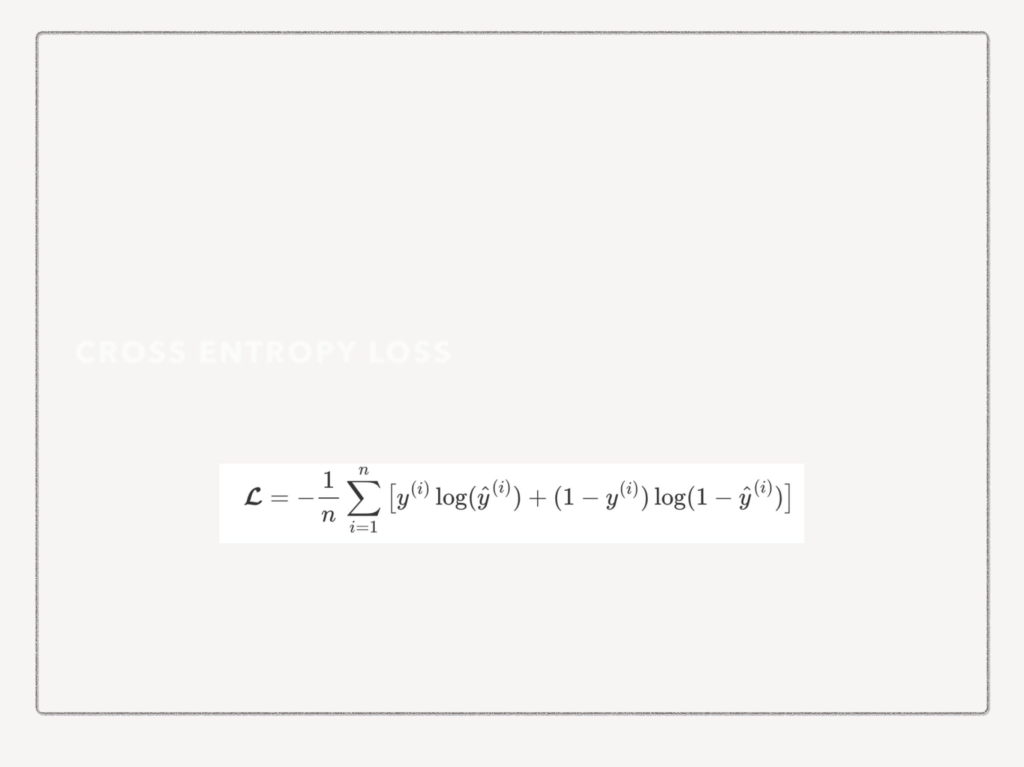

**CROSS ENTROPY LOSS**